**Team Name**: We Can Do It

**Date of Submission:** 10/31/2021

**Meeting Date & Time:** 10/29/2021 @ 6:00PM

**Meeting Location:** Zoom

**Meeting Duration:** 59 minutes

| **Team Members** | **X = Present** | **Notes** |
| --- | --- | --- |
| Dhari Alenezi | X |  |
| Abdulrahman Alharbi | X |  |
| Elina Do | X |  |
| Andrew Nguyen | X |  |

**Progress:**

**Team accomplishments for the week:**

This week, our team created an easier way to upload PDFs onto our app. We have been contacting the WPD to set up a date to test our app with multiple officers. We also revised and finalized a schedule for these upcoming weeks with important dates to get things moving. In addition, we met with our last TPR team for them to review us and started on our TPR report.

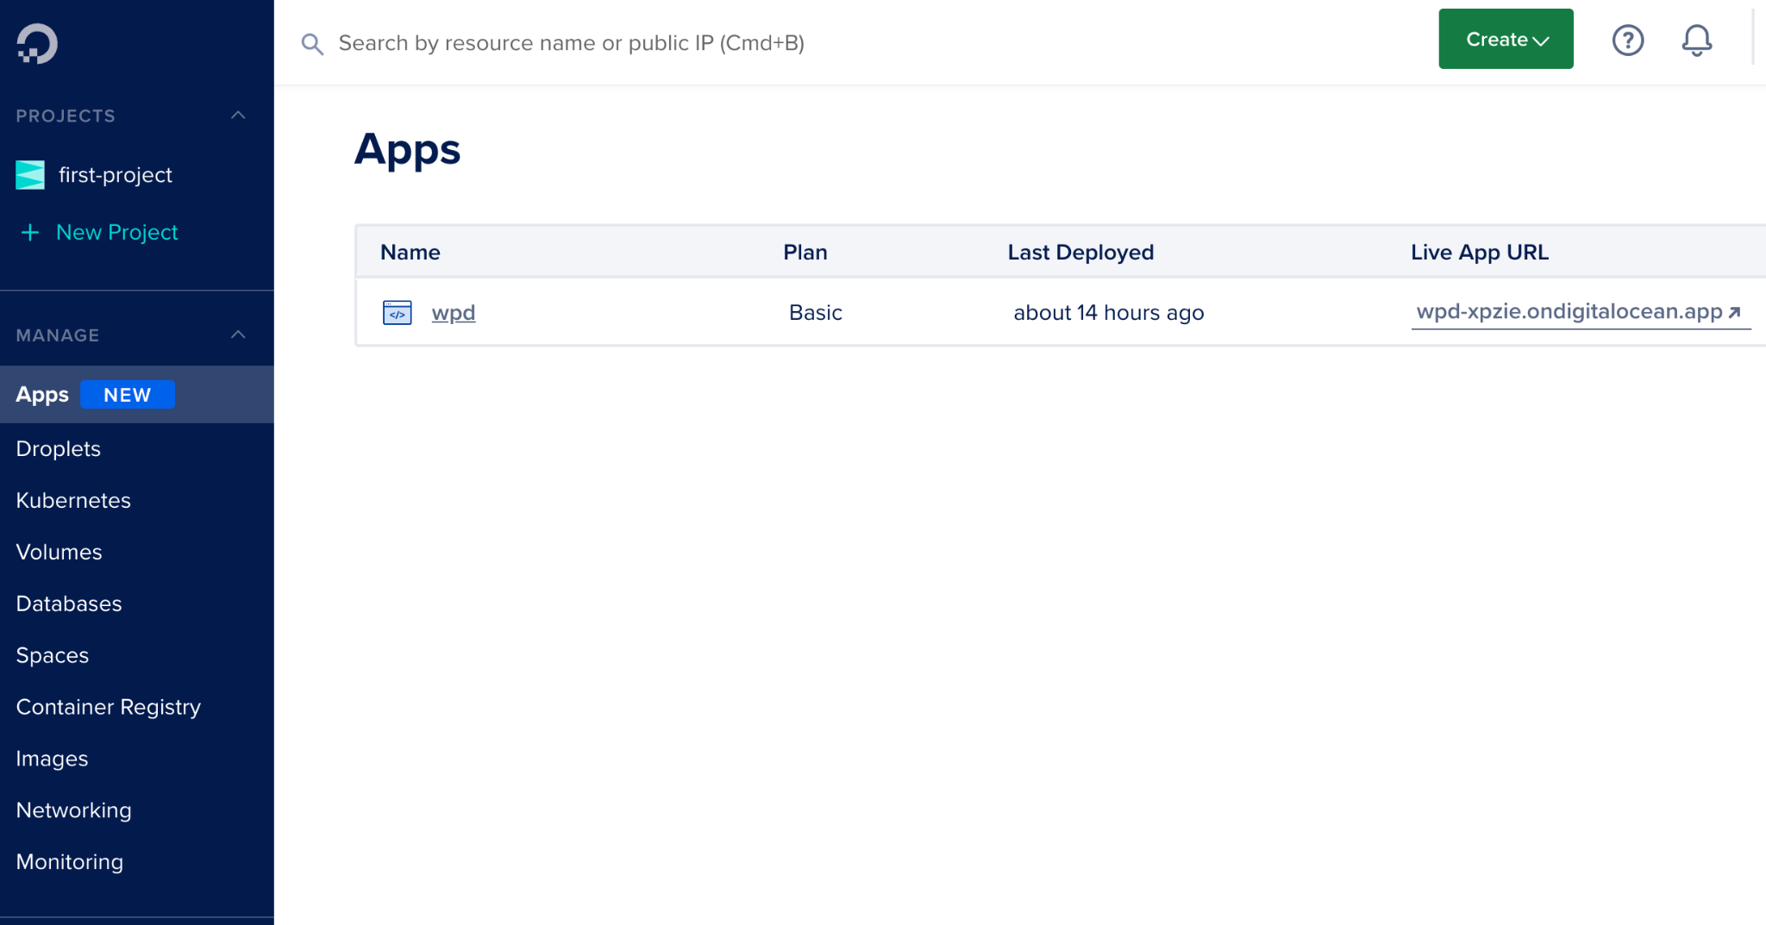

*Moved the backend server to the* ***Digitalocean*** *server*

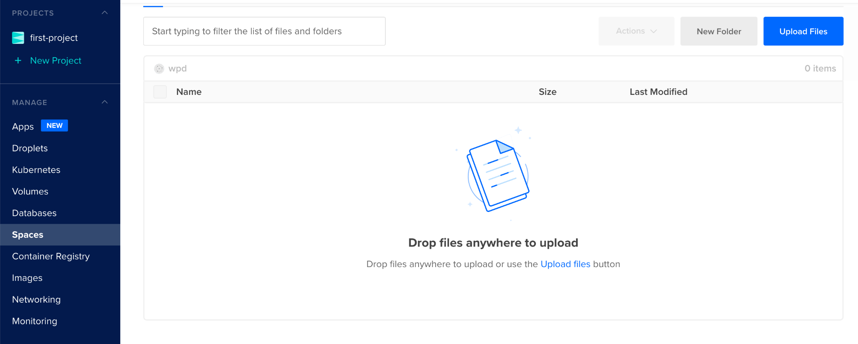

***SPACES OBJECT STORAGE*** *will help us to upload PDF files*

**Individual contributions:**

**Dhari Alenezi:** This week, I moved the backend server from Heroku to the Digitalocean server. Also, I did some research on how to use the SPACES OBJECT STORAGE from the Digitalocean server which will help us to upload PDF files, and generate a URL for each PDF file.

**Abdulrahman Alharbi:** I am researching into the softwares to use in making a user guide manual for the app. And the tutorials for using the software to build a user guide manual.

**Elina Do:** Looking into different methods on taking the database offline and have been in contact with the WPD to create a timeline for the coming weeks.

**Andrew Nguyen:** Researching how to implement google translate to translate the information on the website.

**Project Tracking:**

| **Team Member** | **Assignment** | **Due Date** | **% Complete** |
| --- | --- | --- | --- |
| Dhari Alenezi | Test the application on the Web and the Windows platform. | 10/30/2021 | 60% |
| Abdulrahman Alharbi | Working on building user guide manual | 11/18/2021 | 5% |
| Elina Do | Complete first draft of base code for database in MongoDB | 09/17/2021 | 50% |
| Andrew Nguyen | Create static web prototype for WPD to test and give feedback on | 09/19/2021 | 100% |
| Andrew Nguyen | Link web app with back end to display information | 10/06/2021 | 100% |
| Andrew Nguyen | Minor Improvement for dynamic page of web app to present the data | 10/22/2021 | 100% |
| Andrew Nguyen | Add in a Google translate function to translate | 11/06/2021 | 0% |

**Plan:**

| **Assignment** | **Due Date** |
| --- | --- |
| Setup PDF storage | 11/6/2021 |
| Developing last activity History feature | 11/11/2021 |
| Develop the feature that helps the police to choose multiple cases inside one QR code. | 11/12/2021 |
| Developing the cache feature for the mobile app | 11/13/2021 |
| Testing both the frontend & backend sides | 11/14/2021 |
| Web App final review | 11/14/2021 |
| Web App finalized and ready for presentation | 11/28/2021 |
|  |  |
|  |  |
|  |  |
|  |  |
|  |  |

**Issues:**

Include the schedule for the next meeting:

Meeting Date & Time: 11/05/2021 @ 6:00PM

Meeting Location: **Zoom**